How Print Business Can Create An Online Presence With Zero Investment?

Title Options -

- How Small Print Business Can Create An Online Presence In Minutes?
- How PSPs Can Get Started Online With No Effort & Investment?
- How Print Companies Get Online With No Hassles?
- How PSPs Can Get Their Business Online To Improve Sales?
- How PSPs Can Improve Online Orders With No Investment?

Undoubtedly, the pandemic has forced small print businesses to rethink their strategy and approach. Buyers prefer to research online, check out influencer accounts before even visiting the physical to make buying decisions. Online peer-to-peer interactions also play a major role in shaping the buying decisions. 1 in 3 small business leaders are looking to accelerate their digitization initiatives and more than half of them say that technology drives their consumer interactions reports Small and Medium Business Trend.

Manyatimes, due to the lack of exposure and time, print shops hesitate to build an online presence. In reality though, building an online presence is an easy task. Besides, an online presence helps businesses establish trust and to get started one can take the help of their employees, students around them or friends. 97% of people learn more about a local company online than anywhere else; you want to make sure you make it very easy for searchers to find your business (SEO Tribunal).

For instance, one has to follow a few simple steps on Facebook to create an account. They can add business logos, contact numbers, addresses, add friends (employees) with attractive pictures of their office, product videos and much more. First-time users can open a social media account via their smartphone in minutes. Users can convert their phone into a mobile studio to keep the interactions going on the platform.

What’s more is that clients can leave reviews on the Facebook page of the print business. These organic reviews/ visits help generate repeat business when managed well. Study says that 97% of consumers report that the customer reviews influence their purchasing decisions (websitebuilder.com). Therefore, it becomes imperative for businesses to give an interactive platform to their customers.

Here are the local free listings but there are others such as Bing, FourSquare, Mapquest etc,. Which print businesses can choose as per their area preference.

Local Listings

- Google My Business (GMB)

A study by Bright Local, an average business on Google My Business (GMB) is found in 157 direct searches each month, and 852 discovery searches. This totals an average of 1,009 searches per month. And 49% of businesses receive more than 1,000 views on Search per month.
GMB helps businesses to effectively and accurately increase their chance of being found, by being included in - Google Maps, Google’s Local Pack and Local Finder.

For instance, an ABC print shop can create a GMB profile and add their office address, their opening and closing hours so people can easily find them. Moreover, the printer can request clients to add reviews of their services. Providing the contact details will also help the business get in touch with clients directly. This will help the business be easily recognised by Google algorithms and help new buyers to make their decision.

It allows businesses to increase their organic rankings by -

- Displaying their opening and closing hours, address and lets customers book appointments and services straight from the business’s GMB profile
- It encourages businesses to take reviews from customers, naturally and ethically, and how to respond to those reviews to establish trust
- Lets businesses create posts around any deals and promotions to indicate the business is open and active.

Claim and verify your business on GMB today.
Get your business on Google

- Yellow Pages

According to a study by the Local Search Association, 8 out of 10 consumers look in the Yellow Pages to find local businesses. 91% of people who use the Yellow Pages phone book follow up on ads by contacting the business and each month 7 million shoppers turn to the phone book (Yellow Pages for business).

For instance, the ABC print shop is listed in the directory. This will help clients get their details quickly and simply call them to make an appointment or place an order.

Today the traditional print directory has gravitated towards the digital space.
Free business listings has its perks, such as -

- Hyper-local geographic targeting especially for print businesses concentrated locally
- Specific targeting via industry type the business is a part of and/or products or services the business offers
- The digitization of Yellow pages will let targeting add-ons to allow your business listing to be seen by customers in additional locations. These locations can be defined by area codes to be effective

To find out the best print advertising options for your business.
The Real Yellow Pages® | YP.com

- Just Dial

Just Dial is one of India’s most trusted local listing services. Its organic traffic has recovered steadily from the impact of COVID-19 and risen by 15.6% to 132 million (medianama.com). This means more business visibility and local search related services via multiple platforms such as laptop/ desktop, mobile apps (Android, iOS, Windows), website, mobile site, over the telephone and text.

It offers reliable dial-for-help service along with routing queries through its website and mobile internet and SMS-based search services; to offer its customers access to fast, reliable and comprehensive information on businesses, products and services across India.

Recently, it launched its new B2B portal called Jd Mart. This will be an exclusive portal offering new wholesale experiences. It will allow B2B buyers to discover quality vendors offering a wide selection of products across various categories for their business needs.

So get your business noticed with Just Dial.
Justdial - Local Search, Social, News, Videos, Shopping

Social Media

- LinkedIn

LinkedIn is a B2B goldmine. It’s where the Fortune 500 decision makers like to spend their time. And here they are actively searching for content to enhance their way of doing business. The platform is responsible for generating 97% of the business’s social media leads (Neilpatel.com).

For instance, the ABC print shop has a LinkedIn page. The client can simply learn more about the printing services, talk to their representative on chat, follow posts to know what’s new in the company and even place custom orders.

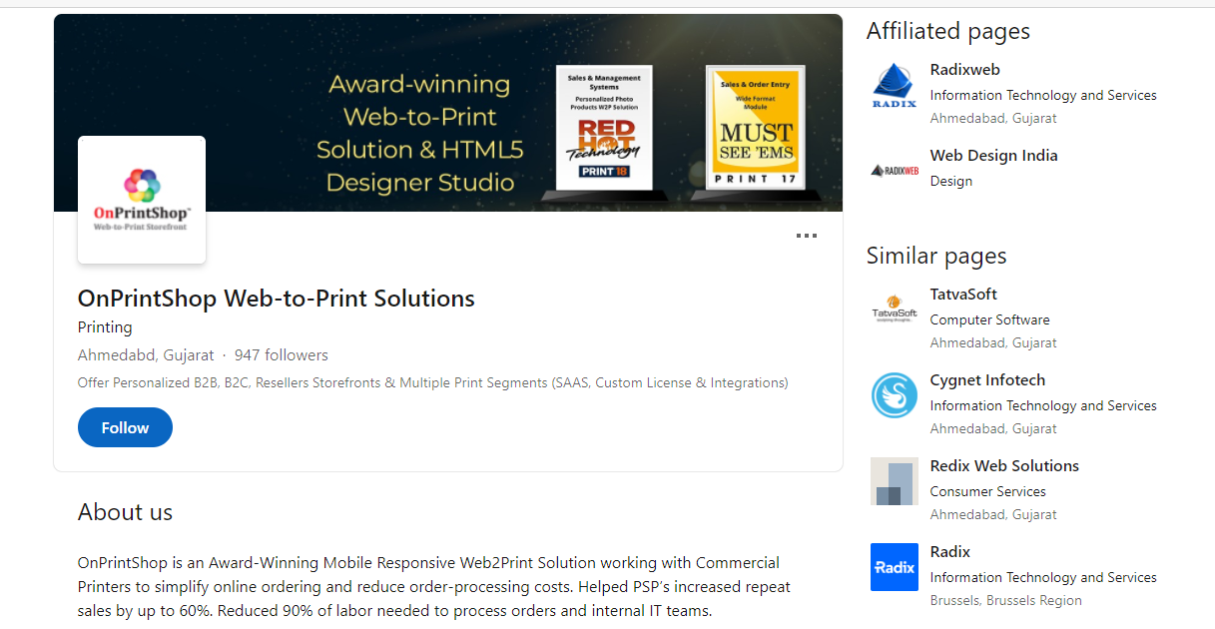

LinkedIn offers a supportive and trusted environment to businesses to -

- Build a strong online presence which resonates and drives 10–15% lift in short-term sales performance (LinkedIn internal data)
- Create virtual events, live streams, LinkedIn ads and sponsored messaging with no hassle
- Create engaging content for its 700+ million members spanning a vast array of professions, functions, interests,, and career paths

To leverage LinkedIn in the best way possible, join today.
LinkedIn Login, Sign in | LinkedIn

- Facebook

Facebook has more than 200 million small businesses using its tools around the world and 2/3rds of its users report visiting a local business page weekly (Facebook.

With Facebook Pages a business can create their online presence in minutes. They can publish their business information such as their operating hours, contact details, their products and services, policies and brand culture to increase their brand presence.

The platform offers a number of benefits such as -

- Access to the world's largest communities and potential marketplace. Facebook is the leading social media platform reaching out to 59% of social media users (eMarketer, 2020)
- Streamline communication by directly responding to consumer queries posted on the business page

Get started with connecting and engaging your customers now.
Facebook – log in or sign up

- YouTube

YouTube is an invincible business resource that allows businesses to build brand awareness and generate leads. Over 65% of users say YouTube content feels like real life (thinkwithGoogle.com) and 51% of YouTube users visit the site daily (spendmenot.com).

The video content on the platform is relatable and users feel connected to it. This is important for Gen Z customers who value authentic marketing even more so after the pandemic.

For instance, the ABC shop making videos for its YouTube channel can connect better with their audience. They can show how the printer process work, what benefits the clients have in associating with them, what are other clients saying about the business and much more.

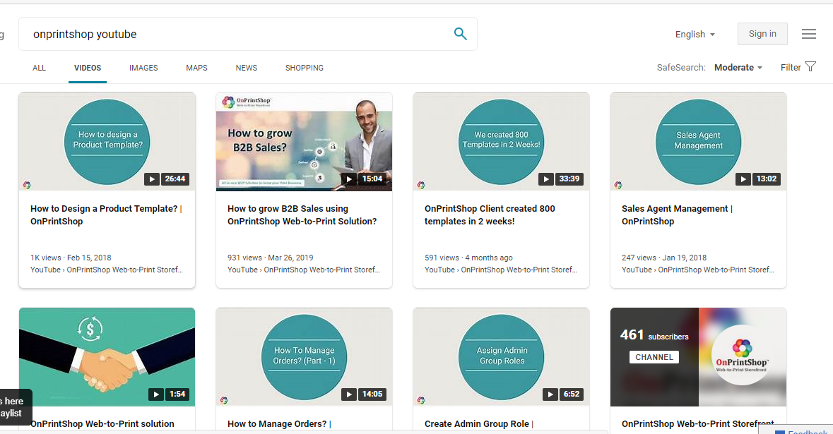

Let's look at the compelling benefits of YouTube for businesses -

- Videos increase engagement and retention. They are easier to understand and have a high recall value. Statistics indicate that Users are watching 1 billion hours of YouTube videos daily and it has more than 2 billion monthly active users (YouTube)
- Video content has recorded 49% faster growth in revenue than those other forms of content. Plus the video is easy to target and hence readily gets picked by Google AI
- Videos act as a great referral for the business’s product and services as they are easy to share

Discover the power of video for your business with YouTube.
YouTube

- Instagram

Instagram is rapidly evolving as the preferred platform for young adults. Just being on the social media platform is a boon for businesses. An Ipsos survey conducted on behalf of Facebook found that 66% of people say they use Instagram to interact with brands.

Its users make a purchase decision based on what they see while browsing. Influencer marketing too is a huge reason behind these purchase decisions. Marketers can make $5.20 for every $1 invested in influencer marketing (Influencer Marketing Hub).

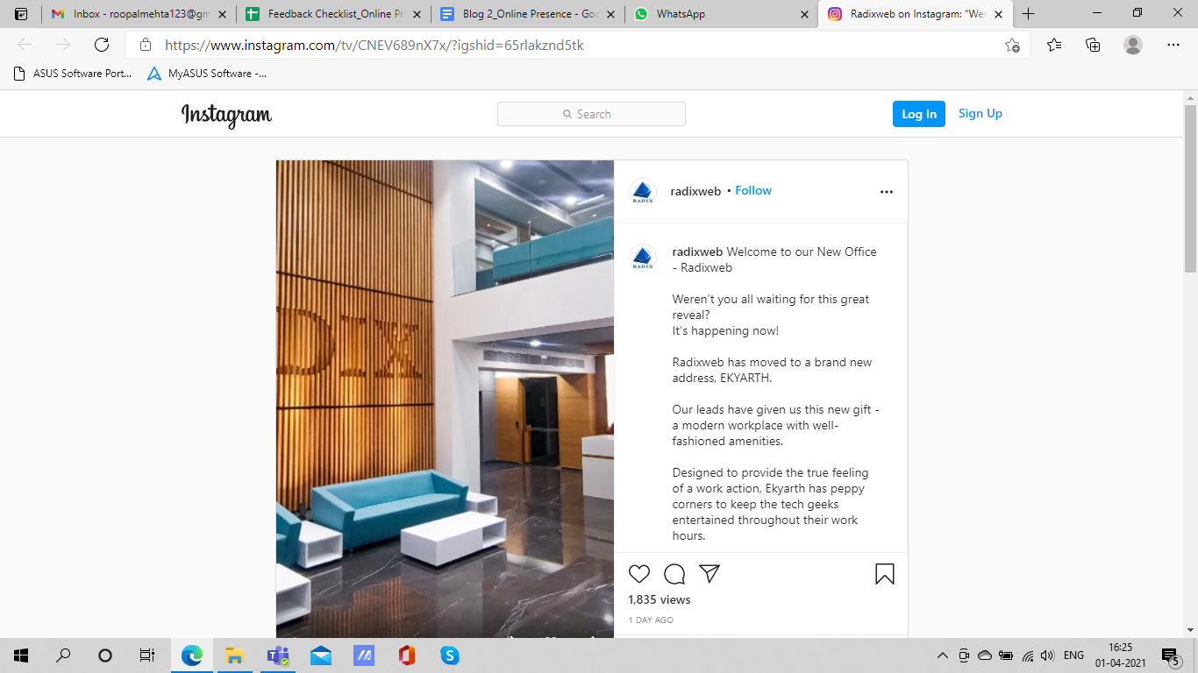

The platform lets businesses get creative and engages users -

- Via Instagram ads, creative Instagram stories (having 500 million daily active users alone, says Instagram) and relevant Instagram hashtags
- It's a highly visual platform which lets users interact with photos, add comments, view stories, and send direct messages
- MobileMonkey says that updating the business profile link in the bio section gives an important edge for success on the platform
- The platform helps to monitor clicks and keep track of leads

To be an influencer on Instagram begin your journey here.
Instagram

The Bottomline

Print businesses must not shy away from creating a viable online presence due to fear or ignorance. When in fact the skill of putting up business information online is easy to acquire, accessible and free of cost. From products to services to information in the form of e-books, print businesses must be open minded to get everything online for their customers.

A notable online business presence will help shield print businesses from the effects of the lockdown and ups and downs of the economy by offering a much larger customer base and opportunities.

- For consultation to optimize your Print Order Management and know more about OnPrintShop, feel free to contact us at biz@onprintshop.com

